# Export your CA Certificate

## *Follow the steps below to export your CA Certificate.*

# 

# Start the Microsoft Management Console > Run mmc.exe

# 

# 

# 

# Click the 'Console' menu and then click **'Add/Remove Snap-in'**.

# 

# 

# 

# 

# 

# 

# 

# 

# 

# 

# 

# 

# 

# 

# Click the '**Add**' button and then choose the 'certificates' snap-in and click on 'Add'.

# 

# 

# Select '**Certificates**' and click 'Add'.

# 

# 

# Select **'My User account'** then click 'Finish'.

# 

# 

# 

# click 'OK'.

# 

# 

# Expand the menu for '**Certificates**' and click on the **‘Trusted Root Certification Authorities'** folder then

# right click on the CA certificate which we configured and select **'All tasks' > 'Export'**.

# 

# 

# 

# A wizard will appear. Make sure you select **‘Base-64 encoded X.509 (.cer)’** then click **‘Next’**.

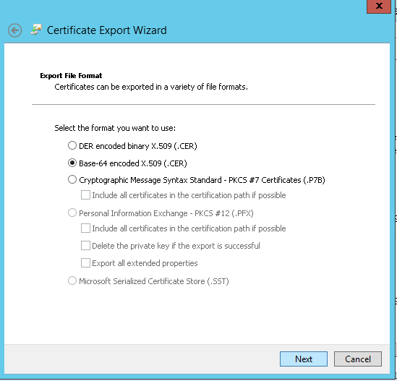

# 

# 

# Select destination where you want to export certificate then click **‘Next’**.

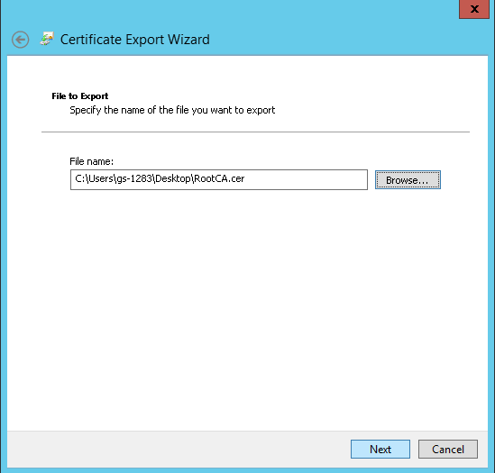

# 

# click **‘Finish’**.

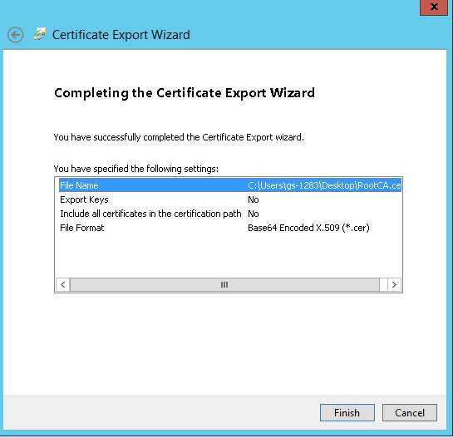

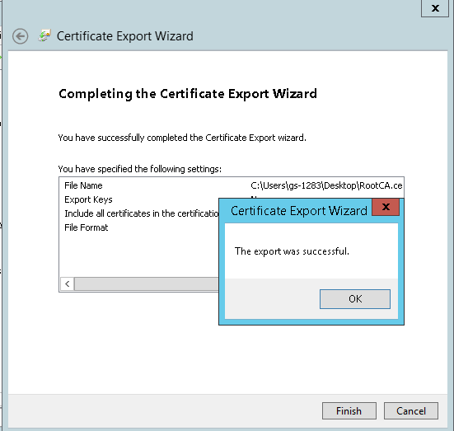

## *Then just rename extension of exported certificate to .crt from .cer*